**Exploratory Data Analysis Lab**

**Code: PMDS604P**

**Digital Assignment 5**

**Name: Soumyadeep Ganguly**

**Reg. No.: 24MDT0082**

**Course: M.Sc. in Data Science**

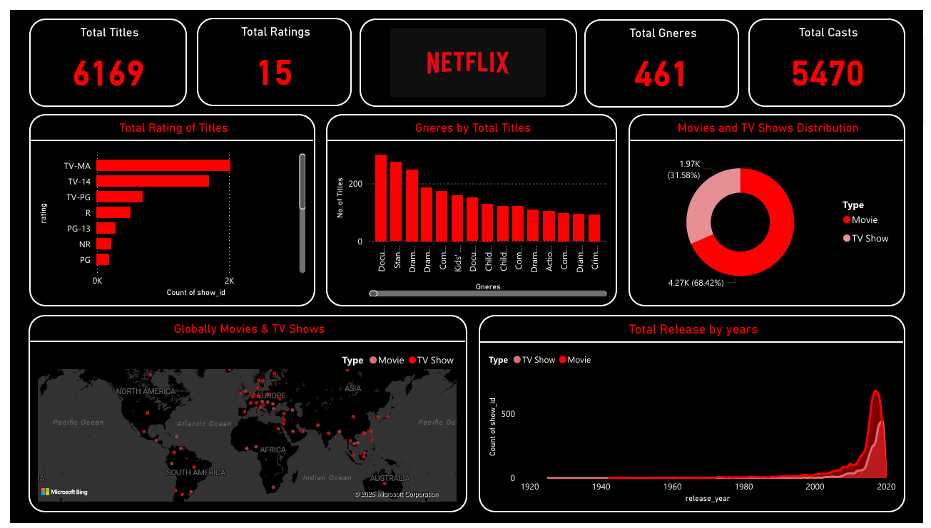**Power BI Dashboard: Netflix Data Analysis**

**Narration: Netflix Data Dashboard**

This dashboard provides an insightful overview of Netflix's content library using a dark-themed design with red highlights to maintain visual consistency with Netflix's brand identity. The layout is structured into multiple sections to present key statistics, trends, and distributions effectively.

1. **Key Metrics Overview**  
   At the top, four prominent metric cards display the total number of **titles (6169)**, **ratings (15 unique ratings categories)**, **genres (461)**, and **cast members (5470)**. The large, bold red text ensures high visibility and immediate impact.
2. **Total Ratings of Titles**  
   A horizontal bar chart highlights the distribution of content across various rating categories. The **TV-MA** and **TV-14** ratings dominate, indicating a focus on mature audiences. The colour red draws attention to the most frequent ratings.
3. **Genres by Total Titles**  
   The bar chart on the right categorizes content by genres, showing the **dominance of documentaries (Docu.), stand-up comedy (Stan.), and drama**. The use of red bars against a black background enhances readability.
4. **Movies and TV Shows Distribution**  
   The donut chart in the middle-right visually represents the proportion of **movies (68.42%) vs. TV shows (31.58%)**, providing a quick glance at the content split.
5. **Global Distribution of Netflix Titles**  
   The world map marks locations of Netflix titles' production or popularity. Red dots on different continents visually convey the global reach of Netflix content.
6. **Total Release by Years**  
   The timeline chart at the bottom right captures the **growth in content releases over the decades**, with a notable surge in the 2010s and 2020s. The color gradient emphasizes the increasing density of releases.

**Design Choices**

* **Dark Theme:** Red and white elements stand out against the black background, ensuring clarity and reducing eye strain.
* **Consistent Use of Red:** Highlights important data points and aligns with Netflix’s branding.
* **Chart Selection:** Bar charts, pie charts, maps, and line charts provide diverse perspectives for different insights.
* **Strategic Layout:** Key metrics are placed at the top, while trends and distributions are below for a logical data flow.

This dashboard effectively combines aesthetics with functionality to provide a compelling visual narrative of Netflix’s content library.

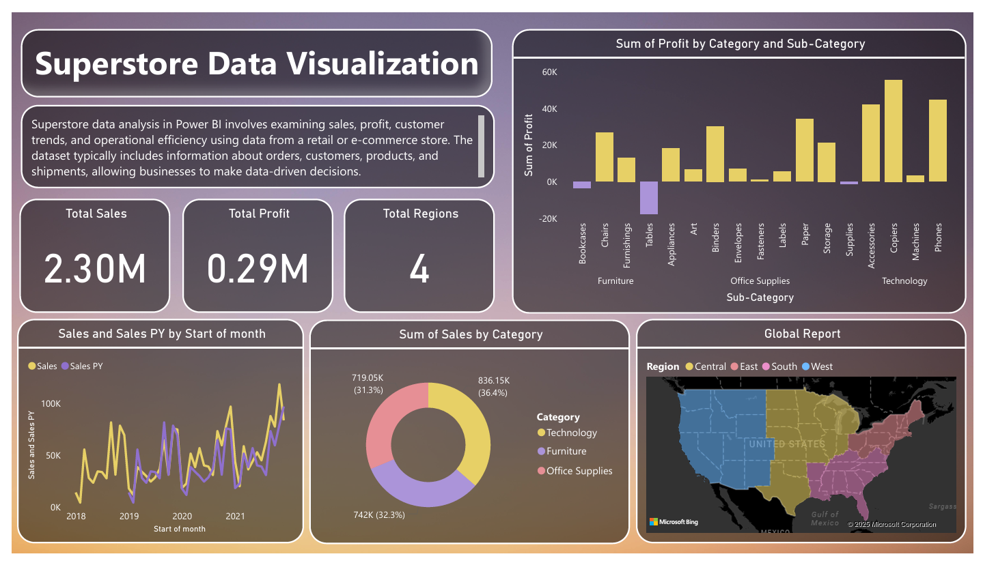**Power BI Dashboard: Superstore Data Analysis**

### Narration: Superstore Data Dashboard

This **Superstore Data Visualization Dashboard** provides an analytical view of sales, profit, and regional performance for a retail or e-commerce store. The dashboard effectively utilizes a **gradient background with soft pastel tones** to create a visually appealing and modern design.

#### **Key Metrics Overview (Top Section)**

At the top, three key performance indicators (KPIs) are prominently displayed:

* **Total Sales (2.30M)** – The overall revenue generated.
* **Total Profit (0.29M)** – The net earnings after expenses.
* **Total Regions (4)** – The number of distinct geographic regions analysed.

These high-level figures are displayed using **large, bold typography**, making them instantly recognizable.

#### **Sales Trends (Bottom Left Section)**

A **line chart** titled Sales and Sales PY by Start of Month visualizes the sales trend over time.

* The **yellow line represents actual sales**, while the **purple line represents prior year (PY) sales** for comparison.
* The pattern shows a general upward trend, indicating **growth over the years from 2018 to 2021**.

This visualization allows businesses to assess seasonal trends and year-over-year improvements.

#### **Category Sales Breakdown (Bottom Middle Section)**

A **pie chart** displays the proportion of sales across three major categories:

* **Technology (36.4%)**
* **Office Supplies (32.3%)**
* **Furniture (31.3%)**

The color-coding ensures clarity, making it easy to identify which category contributes the most to total sales.

#### **Profitability by Category & Sub-Category (Top Right Section)**

A **bar chart** titled Sum of Profit by Category and Sub-Category provides deeper insights into profitability:

* **Yellow bars represent profitable sub-categories**, such as **Phones, Machines, and Chairs**.
* **Purple bars indicate losses**, with **Tables showing negative profit**.
* This visualization helps decision-makers identify high-margin and loss-making products.

#### **Regional Sales Performance (Bottom Right Section)**

The **Global Report map** color-codes the four regions (**Central, East, South, and West**) to show geographic distribution. This helps businesses understand **regional sales performance and market potential** across different U.S. regions.

### ****Design Choices****

* **Soft Gradient Background:** Creates a visually engaging and professional look.
* **Consistent Colour Coding:** Yellow, purple, and red distinguish key elements across different charts.
* **Balanced Layout:** KPIs at the top for quick insights, with detailed breakdowns below.
* **Combination of Charts:** Line, pie, and bar charts provide a **multi-dimensional analysis** of sales and profits.

Overall, this dashboard effectively **summarizes retail data**, enabling data-driven decision-making in business operations.